Vivaan LMS Analysis for Change Requests
Analysis and Document prepared and performed by Tracy Tran, Director of Sales and Program Management, Aan Systems

Previous Credentials from Team:

The BigBlueButton is integrated along with the new UI and available in the URL ‐ http://52.14.195.175/vivaan‐lms/ username ‐ superadmin@vivaanlms.com
password ‐ admin@123

BigBlueButton testing with ‐ 1 moderator and 4 attendees, is done by Dinesh

Branding for BigBlueButton is in progress Date: July 20, 2018
Dinesh, Mahesh, and I did a demo on the Vivaan LMS system today with a few prospective partners and we found some bugs and shortcomings in the LMS system that needs immediate attention and change suggestions to make the system more robust please. Below is a list of change requests for the Vivaan LMS system. Please read through the list and make the changes and/or address the following concerns please. Thank you in advanced:
- 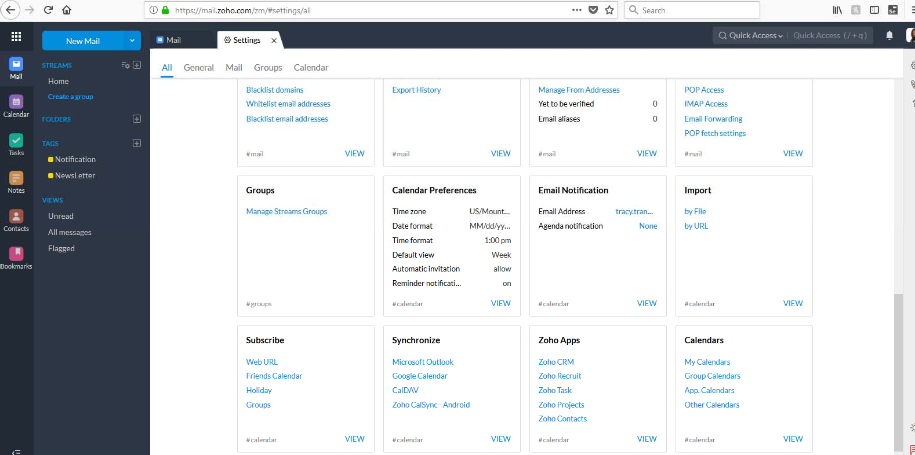In Vivaan LMS Remove the time expiration of the meeting link created from its default of 5 minutes and make it unlimited. The moderator should be able to schedule meetings ahead of time and have it saved in the calendar. Maybe the Vivaan LMS systems could have sync integration with Google Calendar/outlook/Zoho calendar so that meeting events that are created from the Vivaan LMS could be synchronized to popular calendars. Zoho calendar currently syncs to your existing google calendar, etc. Here is a screenshot of Zoho settings showing synchronization features to other calendars.

- When creating a meeting in Vivaan LMS, the moderator should be able to set the exact time & date that they want the meeting to start just like in Google Calendar (i.e. 6:30 pm IST), instead of just specifying a duration.
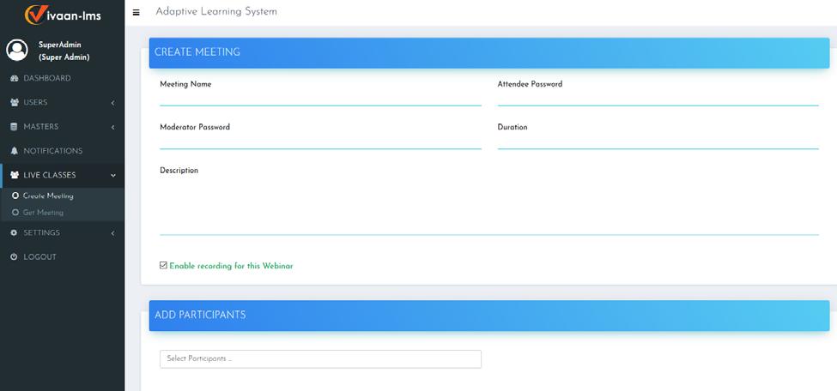

The Vivaan LMS should have a calendar type feature that you can just click on the day and time to set up the exact meeting time in the exact time zone that the moderator chooses. The participants will be emailed and notified, and the event put on their calendars that notifies them of the event in their time zone.
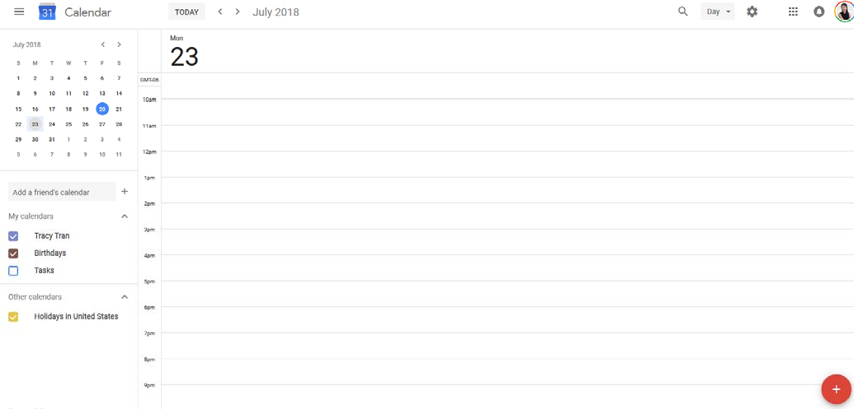

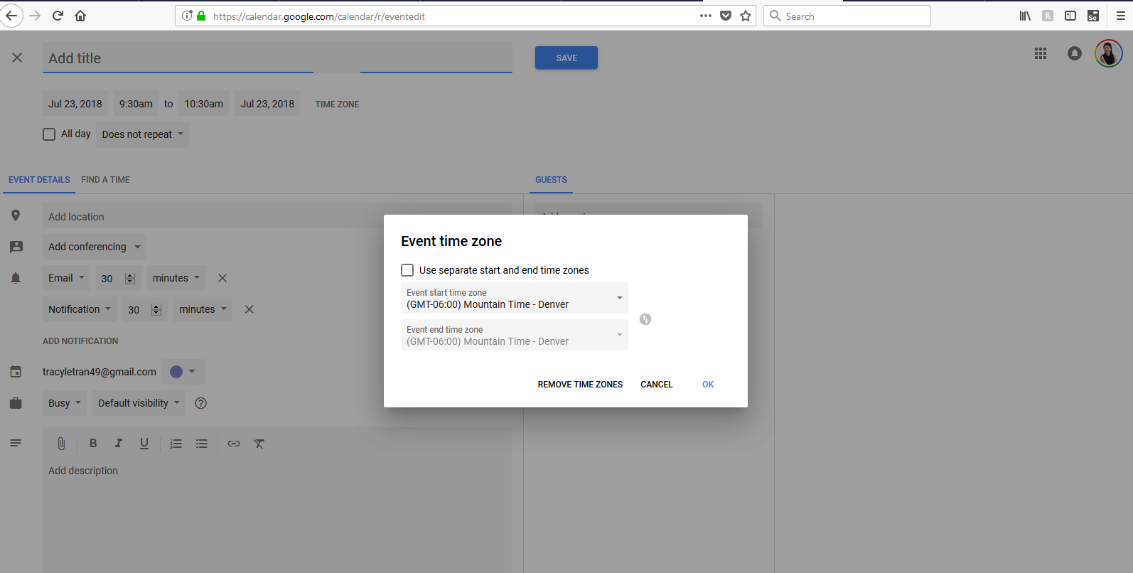

- When adding participants, the Vivaan LMS system could have a feature that creates participants under groups to save time in creating future meetings.

Example: Company A = Employee 1, Employee 2, Employee 3, Aan Group 1 = Tracy, Mahesh, Adi, Raghu, Dinesh

Then, when I create a meeting, I could add: Aan Group 1 and Company A. The system will show that I’ve added the following participants: Employee 1, Employee 2, Employee 3, Tracy, Mahesh, Adi, Raghu, Dinesh. You could pre‐ save groups of participants and then add them quickly when making your meetings.
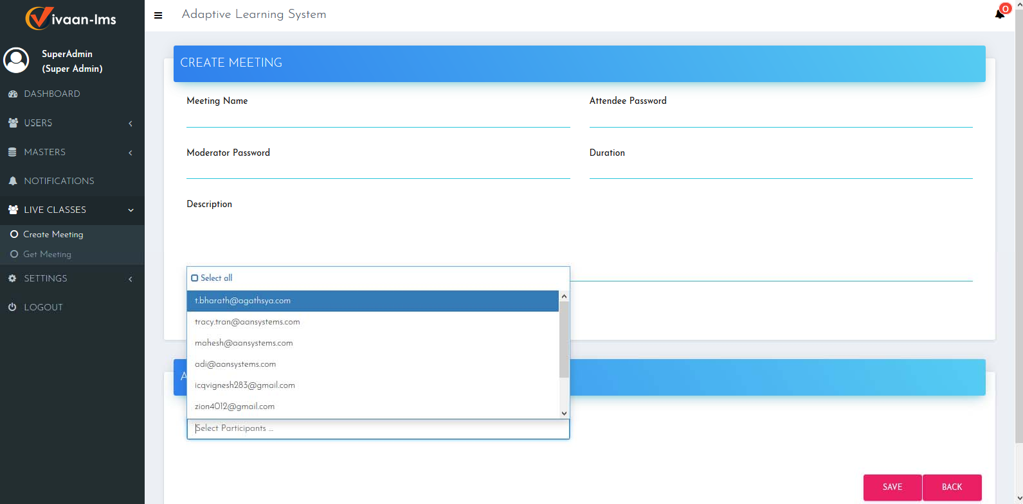

- This upcoming meeting list should list the exact time and date of the meetings. They should have a check box to click in settings to synchronize this event to other popular calendars such as Zoho calendar, google calendar, or outlook.
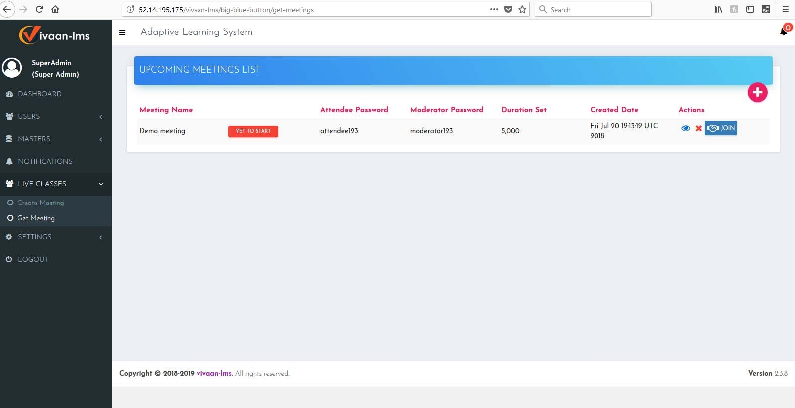

- Sound Integration of the Vivaan LMS conferencing system isn’t working correctly. Vivaan LMS test: I’m currently testing the system using two different computers and logins and can hear sound from the microphone. It only works on Mozilla Firefox and not on chrome. Logging into the Vivaan LMS doesn’t work on other devices besides computers.

Right now, the Vivaan LMS system will only allow you to change presenters by removing the current presenter. We must be able to change presenters on the whim whenever we want to without having to remove presenters.

- Right now, the Vivaan LMS system screensharing has a view that is not optimized. It should allow the moderator to undock, dock freely, and put the screen up to full view, or resize it as they please. Below is an example of the screen sharing on an attendee looking at the moderator screen in the Vivaan LMS. Notice that the screen is constricted in the diagram below.

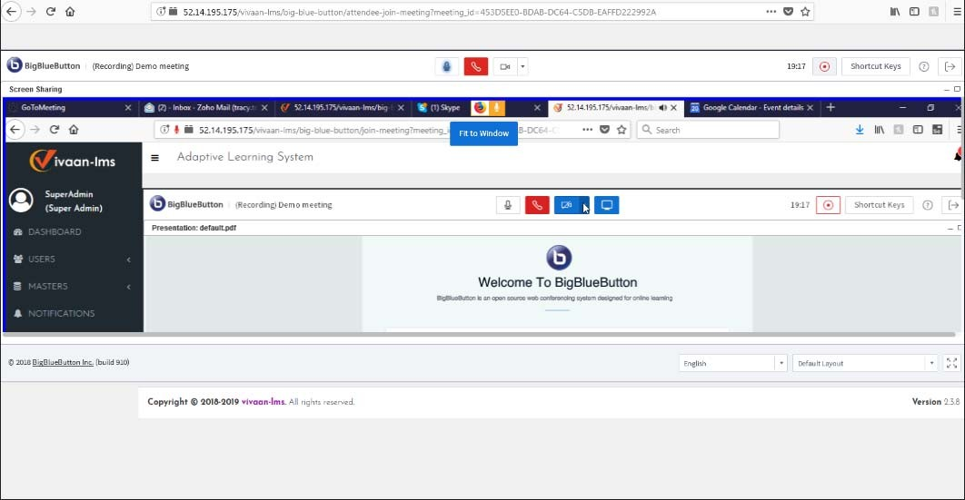

- The Vivaan LMS, should have capabilities for setting a specific login portal meeting name like www.vivaanlms/aansystems or whatever you want to assign to the user when you first create the user. Thus, when creating a meeting, the moderator can use the specific portal meeting name or have a random one generated from the system.

- Vivaan LMS doesn’t log into the system using other devices like phones or iPads, as the login requires flash player at this point. Please try to resolve this issue and make it flexible so that all devices can be accommodated for.

- Google Chrome currently doesn’t support the microphone for Vivaan LMS and I have to revert to using a different browser like Mozilla Firefox. Please try to resolve this issue and make it flexible across any browser or device.
(The error message comes up saying: This server is not configured with SSL. As a result, Chrome disables sharing of your microphone.) Chaithra says that “Mahesh needs to purchase the SSL certificate for www.vivaanlms.com, as the new UI release of the BigBlueButton requires the SSL certificate and audio and video will not work without SSL.”

- 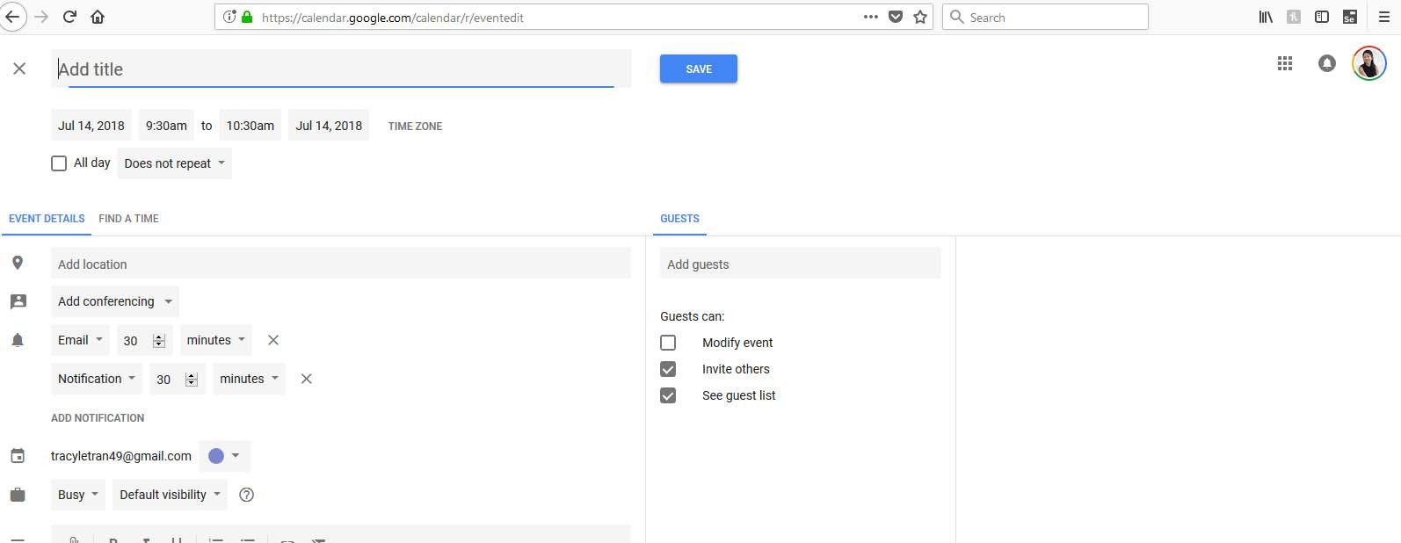The Vivaan LMS system currently bombards the user with so many notifications, almost to the point of spamming. Please make it so that we can customize when notifications are sent out. For example, in Google Calendar you can see it that you can select the frequency of notifications and when they get sent out, and one is sent out when you create the meeting. The system should ask you for confirmation if you want to send out the email. You click yes or no. Here is a screenshot of how notifications can be specified in Google Calendar right now.

- Fonts and views of document shares look messed up and skewed. During the demo that Mahesh gave and the report that he uploaded into the Vivaan system, the LMS made all the diagrams look all warped, and the fonts and view looked all messed up and skewed to the viewer when he shared his screen. Please double check this and resolve the issue.

- Put a pausing feature in Vivaan LMS during screenshare. On GoToMeeting, when sharing a screen there is a feature for pausing the screen, I do not see the functionality as prominent in Vivaan LMS. When you first do a screen share in Vivaan LMS, it requires downloading the Big Blue Button Screen Share file and accepting the certificate. You do see a pause there, however, as the presentation continues, the pausing feature is not seen anywhere as you can only choose stop screen share. The feature of having you pause a screenshare comes handy into play, for example, when you are presenting to a client and want to find a file on your computer but don’t want them seeing every single move you are doing. Thus, you pause on a valuable screen for them, while you quickly search, then un‐pause and seamlessly go back to the conference without them ever knowing you had to fumble around trying to find your file. I hope this explanation makes sense.

- There should be a feature for the moderator to mute all participants just in case they need to do that.

- I noticed that if the moderator resizes the window on their screen, the user doesn’t see the windows resized on their view.

- Finally, check the branding of the LMS system and make sure the Big Blue Button is replaced with our Vivaan LMS Logo. And I know that Chaithra indicated that the branding is currently in progress now.

Thank you to everyone for a great job. Please read through these change requests and comments and try to make all the changes. Our goal is to be able to demo an entire product, document, and conduct a meeting right on the Vivaan LMS, not

just for our team but for potential clients. Please comment on your progress in skype and don’t hesitate to reach out to me for questions, concerns, feedback.
Thank you, Tracy Tran
Director of Sales and Program Management, Aan Systems

Direct Mobile: 1‐970‐227‐0795 WhatsApp: 1‐970‐227‐0795
Email: tracy.tran@aansystems.com Skype: Live: tracyletran49
LinkedIn: https://www.linkedin.com/in/tracy‐tran‐89792abb/

